Chartiers Hill United
Presbyterian Church
2230 Washington Road
Canonsburg, PA 15317
724-746-1330
August-September 2023 Newsletter

THE TIMES THEY ARE A CHANGIN’!
The last Sunday for 10:00 AM worship is September 3rd. We will move our service back to 11:00 AM on Sunday, September 10th. The choir returns, too!

WORSHIPING THROUGH SONG
We will praise God through song, his Word, and prayer on Sunday, September 3rd at 10:00 AM. It’s a hymn sing and more. Loosen up those vocal chords and join us for an uplifting hour of worship.

CELEBRATION OF THE LORD’S SUPPER: September 3rd
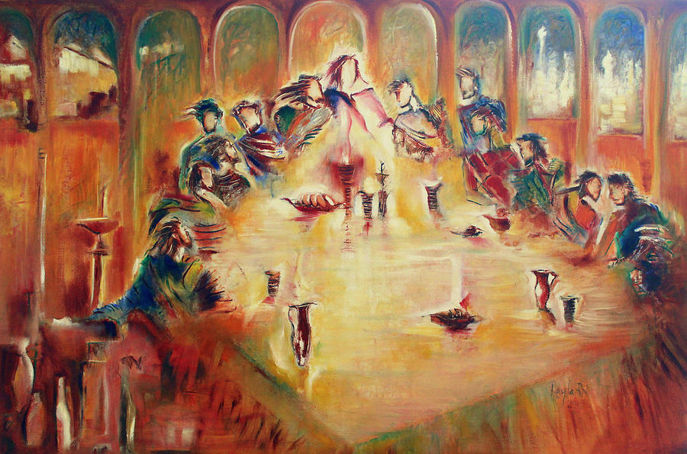
Hill Church celebrates the Lord’s Supper on the first Sunday of every month. As one of the two sacraments of the Presbyterian tradition (baptism being the other), the Lord’s Supper/ Holy Communion/Eucharist is a way to remember Jesus and what he did for love of God’s children. But it is more than a remembrance, Presbyterians also believe that we really do “dine” with our Risen Lord. How can that be since our confession, according to the Apostles’ Creed, says that after the resurrection and ascension, that Jesus is seated at the right hand of God the Father? However, through the power of the Holy Spirit, we know that we are joined with Jesus – the distance between heaven and earth is bridged. There are differences between us and our Roman Catholic friends regarding the Holy Meal. Unlike these believers, we do not propose that the bread and wine are the actual body and blood of the Crucified Lord. There are no corpuscles or platelets in our supper. For Presbyterians, the bread and juice/wine are symbolic of those things. If you’ve visited many Presbyterian churches, you’ve probably not found them to use wine for Communion. There is a very practical reason for that. Although we are certainly permitted to use wine, most churches decide that, risking the sobriety of anyone who struggles with alcohol for the sake of wine instead of grape juice, simply isn’t worth it. And, finally, the Table of God is HUGE! Not only do we trust that we dine with Jesus and our brothers and sisters in Christ on earth, we also partake of this incredible meal with every Christian who has gone before us, and even those who will come after us – again, thanks to the power of the Spirit of God. God knows the guest list – each and every one of us by name, all saints.
The Last Supper painting pictured above is by artist Rayla Noel, who lives in Bangalore, India

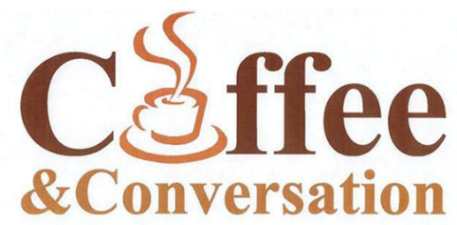
AFTER WORSHIP FELLOWSHIP
If you’d like to host coffee hour following worship, there is a sign-up sheet in the narthex. There are instructions available.

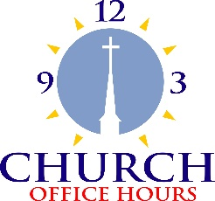
OFFICE HOURS
Ann will continue to be in the office Monday-Friday from 9:00-2:00 PM. Pastor’s office hours will be Tuesday and Thursday 10:00-1:00 PM, and other times by appointment or need.
Office: 724-746-1330 Pastor’s cell phone: 724-554-4555
MAKE A JOYFUL NOISE TO THE LORD!
Thank you to the many gifted people who added music to our summer worship hour.

Bell choir and chancel choir will be starting again soon! The first practice will be September 7 - 6 o’clock for bells and 7 o’clock for choir. Lots of nice music has been chosen for the fall and holiday season. Returning members and anyone else who wants to join will be welcome with open arms. Let’s be able to say once again “Hill Church is alive with the sound of music.” ~ Amy
BLESSING OF THE BACKPACKS
Students of all ages: Bring your backpacks to worship with you on Sunday, August 20th for the Blessing of the Backpacks before school starts!

BOARD & COMMITTEE MEETINGS
Most committees have taken the summer off. Christian Education will meet on August 7th at 7:00 PM in the conference room of the church. The Worship Committee will meet in August. Aaron Hunt will let those committee members know the date and time. The Trustees will meet if needed in August. Check with Roseanne Messerly regarding that. The Session WILL meet in August on the 16th at 7:00. Starting in September, everybody will be back to the usual schedule. If you have items for the elders, please get that information to Pastor by the Friday before their meeting.

THE FLEA MARKET HAS BEEN RESCHEDULED FOR SEPT. 16, 2023
FROM 8:00 AM – 1:00 PM
If you’d like to rent space, the cost is $10/table. See the office or Lynn Thomas. If there are ways you can help: bake for the bake sale, make something for the lunches we sell, help with set up, clean up, serving food, manning the bake sale of lunch table – we’d love to have your smiling face with us. Again, see Lynn Thomas to volunteer. And pray for a sunny, dry day!
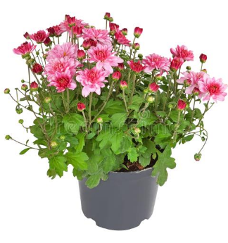
…AND MUMS!
SEPTEMBER 15 & 16 FROM 8:00-1:00
We will be selling mums for your fall garden and front porch. If you can help with this, please contact Nancy Magera. We will need assistance unloading the flowers and setting up in front of the sanctuary building.

A TALE OF TWO MISSIONS ~ Jeff Messerly
The refurbishing of the Don Austin Pavilion is going as planned. We are careful stewards of all donations. So far, we have installed a cement floor and access ramp that will make it easier for members and friends with special needs to enter the pavilion. The Sokol brothers and Gary Woodruff have installed a drainage system around the perimeter of the pavilion. Next on the list is the roof, gutters and downspouts. One of our contractors is trying to get special pricing from a manufacturer for non-profit organizations. This will take some additional time, but it would free up funds for additional amenities, like afternoon shade systems and creating a level and enclosed play area for a small play set.
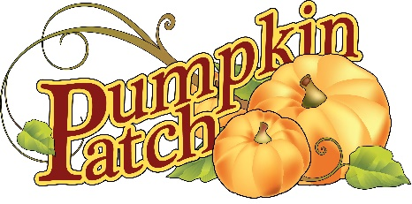
The news is not as comforting regarding our pumpkin patch. We had 50+ pumpkin blossoms, each capable of 2-3 pumpkins each. They were starting to get choked off with weeds. We used a hoe where possible, but it still seemed the plants were choked. Being novice farmers, we researched how to extract the weeds. Evidently the research failed us and the pumpkins. Unfortunately, we lost our harvest for 2023. This is a good place to enter the coined phrase “live and learn”. We are saddened by this but determined to make up for it in 2024. My apologies to all anticipating a pumpkin harvest in October.
TOYS, TOYS, TOYS!
The Canonsburg-Houston Ministerium again asks local churches to help with a much beloved community program to provide toys for local children who might otherwise go without at Christmas. The Toy Chest program does just that. Each year, Hill Church helps by celebrating Christmas in July…and, this year, in August. Thank you for your past generosity. This year will be especially difficult with an ailing economy. Help as you can. And bless you for blessing a child.

BACKPACKS FOR CONNELSVILLE CHILDREN
Hill Church made such a wonderful impact on the children at the school where Kristen Hunt works that the Mission Committee decided to continue again this year to make those little ones our August mission project. If you’d like to help us supply backpacks, please make a donation with “Backpacks” in the memo and place it in the offering plate or to the office. Deadline to give is August 13th. Thank you for your generosity and sharing the love of God with these children.

SEPTEMBER CORN ROAST
Mark your calendars for September 9th when we’ll enjoy a corn roast at the pavilion from 4:00 – 7:00. What to bring:
Last names beginning with A-L bring dessert
Last names beginning with M-Z bring a side
Bring a lawn chair and anything else that would make you comfortable while you enjoy the food and fellowship. Meat, corn and drinks will be provided. If you’d like to donate toward those costs, see Lynn Thomas or Pastor Shannon.

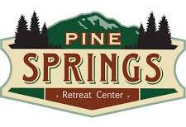
Check out events and retreats at
www.pinesprings.org

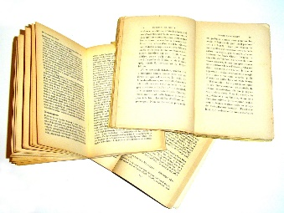
THE LIBRARY…
There has been plenty of opportunity for members to claim books from the church library thanks to Ann Neill, who organized it all. The deadline has passed to claim things and the remaining books will be disposed of. Anything of value is preserved. There are a few items of a Christian Education nature left for the use of teachers.

AUGUST BABIES:

SEPTEMBER BABIES:

